H.T No
Regulations:
A20

Sreenidhi Institute of Science and Technology
(An Autonomous Institution)
Code No: 8B308 Date: 10-Feb-2024(FN)

B.Tech II-Year I- Semester External Examination, Jan/Feb - 2024 (Supplementary)
MACHINE DRAWING AND COMPUTER AIDED DRAWING PRACTICE (ME)

Time: 3 Hours Max.Marks:70

Note: a) No additional answer sheets will be provided.
b) All sub-parts of a question must be answered at one place only, otherwise it will not be valued.
c) Missing data can be assumed suitably.

Bloom's Cognitive Levels of Learning (BCLL)

Remember | L1 | Apply | L3 | Evaluate | L5
Understand | L2 | Analyze | L4 | Create | L6

Part - A Max.Marks:30

ANSWER ANY TWO QUESTIONS. EACH QUESTION CARRIES 15 MARKS.

1. | Sketch the following thread profiles for a nominal diameter of 25 mm and pitch 3 mm and give their applications:  (i) BSW thread, (ii) Buttress thread (iii) ACME thread | L1 | [15M]
2. | Draw the half sectional view from the front, with top half in section and the view from the side of a cotter joint with socket and spigot ends, to connect two rods of 50 mm diameter each. | L1 | [15M]
3. | Draw the sectional view from the front and view from the top, of the following riveted joints, to join plates of thickness 10 mm double riveted zig-zag lap joint | L1 | [15M]

Part – B Max.Marks:40
Part-B (is Compulsory 40 Marks)

4. |  | Assemble the parts of the following figure and draw the following views:  (i) Half sectional view from the front, with left half in section, and  (ii) View from above  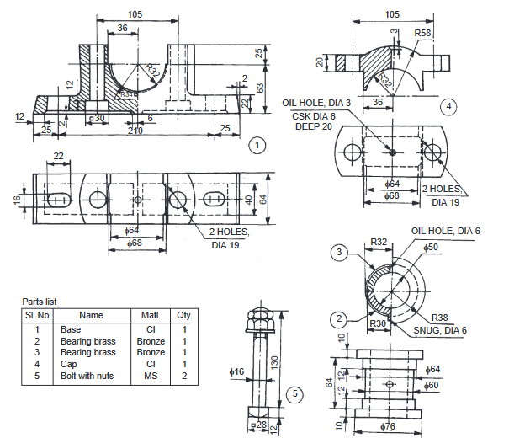 | L4 | [40M]

-- 00 -- 00 –

